

CUSTOMER SUPPORT TICKET
PRIORITY PREDICTION AND
AUTOMATED ASSIGNMENT SYSTEM
USING AGENTFORCE

College Name:KSK College Of Engineering And Technology
College Code:8210
Team Leader:M.Gobi(821023243009)
Team Members:1.M.Ganesh(821023243007),
2.K.Poovarasan(821023243021),
3.B.Pradhap(821023243304)

FINAL PROJECT DOCUMENTATION
Platform: Salesforce CRM
AI Layer: Agentforce
Automation: Auto-Launched Flow
Core Object: Support Ticket Intelligence

TABLE OF CONTENTS:

1. INTRODUCTION
1.1 Project Overview
1.2 Purpose
1.3 Project Objectives
2. IDEATION PHASE
2.1 Problem Statement
2.2 User Personas
2.3 Empathy Map Canvas
2.4 Brainstorming and Idea Selection
3. REQUIREMENT ANALYSIS PHASE
3.1 Customer Journey Map
3.2 Functional Requirements
3.3 Non-Functional Requirements
3.4 Data Flow
3.5 Technology Stack
4. PROJECT DESIGN PHASE
4.1 Problem–Solution Fit
4.2 Proposed Solution
4.3 Solution Architecture
4.4 Data Model Design
4.5 Priority Decision Logic
5. PROJECT PLANNING & SCHEDULING
5.1 Agile Planning
5.2 Product Backlog
5.3 Sprint Roadmap
5.4 Project Tracking
6. PROJECT DEVELOPMENT PHASE
6.1 Salesforce Environment
6.2 Custom Object
6.3 Fields and Relationships
6.4 Flow Design
6.5 Flow Implementation
6.6 Agentforce Configuration
6.7 Agentforce Action
6.8 Input and Output Contract
7. FUNCTIONAL & PERFORMANCE TESTING
7.1 Test Strategy
7.2 Test Cases
7.3 High-Priority Task Validation
7.4 Agentforce Validation
7.5 Test Summary
8. ADVANTAGES & DISADVANTAGES
9. CONCLUSION
10. FUTURE SCOPE
11. APPENDIX

1. INTRODUCTION

1.1 Project Overview
Customer support teams receive a large number of requests and must identify which cases need immediate attention. This project implements a Salesforce-based workflow that retrieves the latest ticket for a customer Account, analyzes its description, determines a High, Medium or Low priority, and returns the handling result through Agentforce.

1.2 Purpose
- Reduce repetitive manual ticket prioritization.
- Provide a conversational interface through Agentforce.
- Use Salesforce Flow as the controlled backend automation layer.
- Create an urgent Task automatically when a High-priority condition is detected.
- Return a clear priority, assigned support level and action message.

1.3 Project Objectives

Objective | Expected Result
Ticket identification | Retrieve the latest ticket linked to the requested Account.
Priority classification | Classify the description into High, Medium or Low using configured conditions.
Automated handling | Create an urgent Task for High-priority cases.
Support assignment | Return an appropriate support level such as Senior Support Agent.
Conversational output | Present the result through Agentforce.

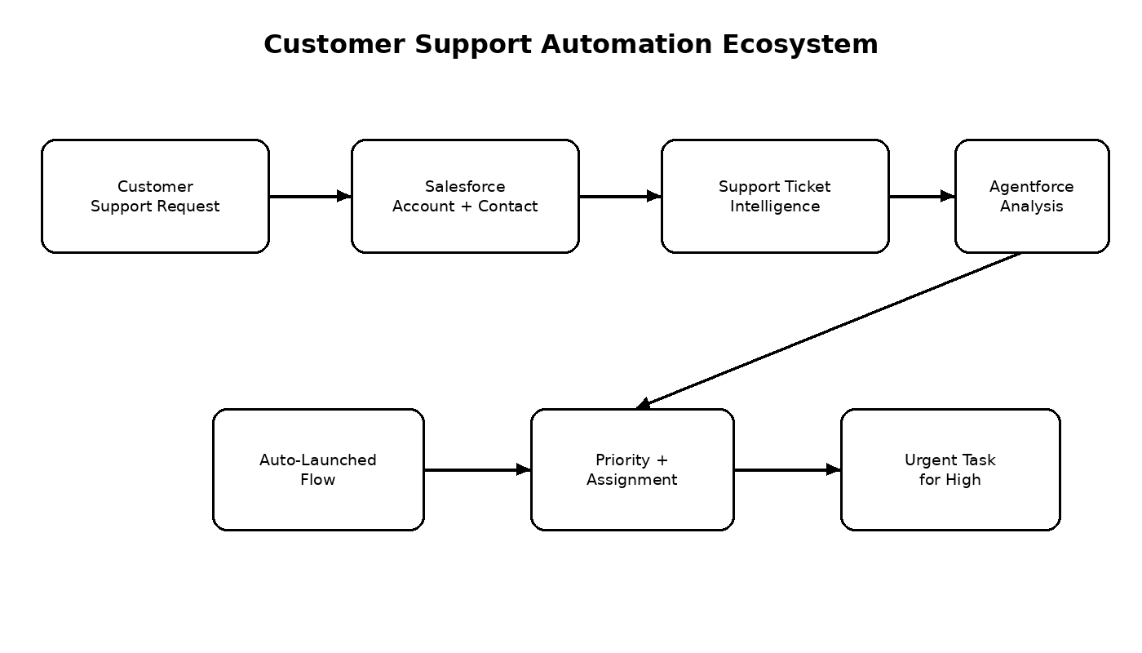

2. IDEATION PHASE

2.1 Problem Statement
Support teams may spend time reading ticket descriptions, deciding urgency and deciding which level of support should handle a case. When ticket volume increases, important urgency signals can be missed or handled inconsistently.

Stakeholder | Need | Current Difficulty | System Response
Support Agent | See critical tickets first | Manual review of descriptions | Automatic priority classification
Customer | Receive quick attention for urgent issues | Critical issues can wait behind other tickets | High-priority handling path
Support Manager | Route work consistently | Assignment decisions can be manual | Configured support-level output
Agentforce | Analyze ticket information | Needs controlled backend action | Agentforce invokes Flow

2.2 User Personas
Persona | Main Goal | Interaction With System
Support Agent | Resolve tickets efficiently | Receives priority and handling information
Customer | Get urgent issues handled quickly | Creates support request
Support Manager | Maintain consistent support operations | Monitors assignment and SLA-related risk
Agentforce | Interpret the request and initiate automation | Collects Account Name and invokes Flow
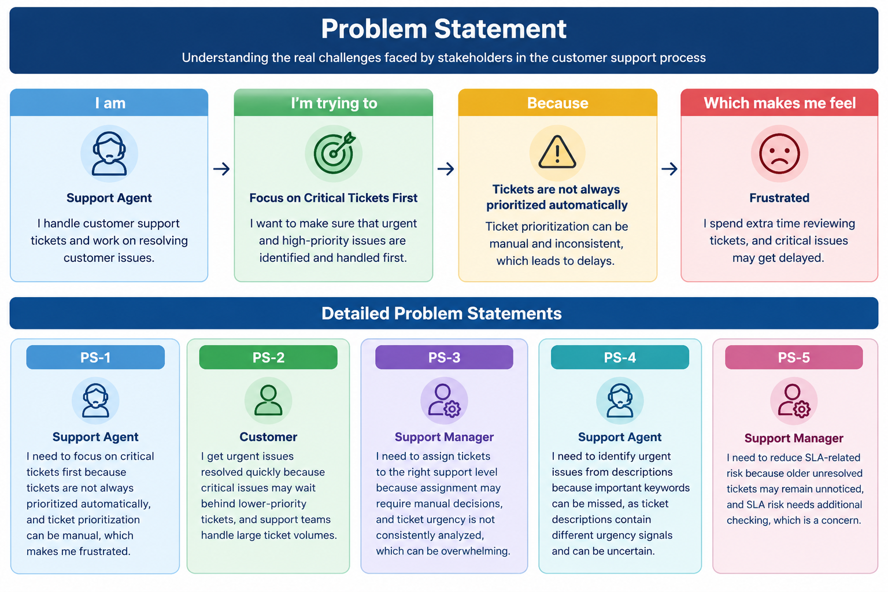

2.3 Empathy Map Canvas
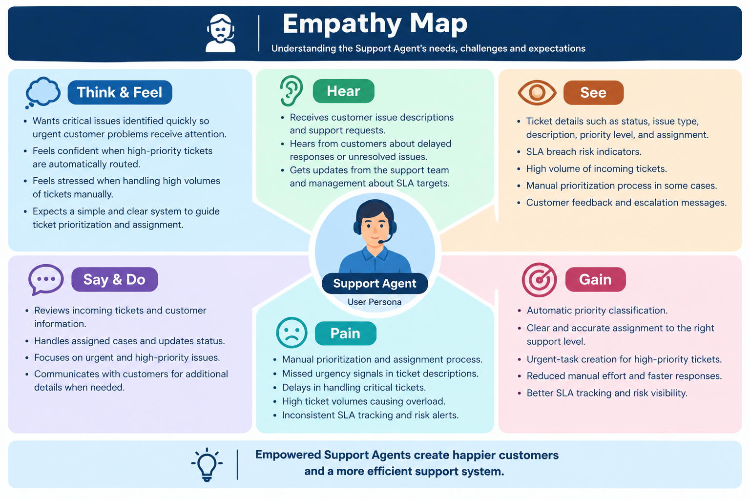

2.4 Brainstorming and Idea Selection

The ideation considered progressively more automated approaches. The selected direction combines CRM data, deterministic backend automation and a conversational AI interface.
- Manual ticket register – simple but highly dependent on human effort.
- Spreadsheet tracking – easy to start but weak for controlled automation.
- Standalone portal – improves interface but requires a separate support platform.
- Salesforce Flow – provides structured backend automation.
- Salesforce + Agentforce – combines CRM data, automation and conversational interaction.
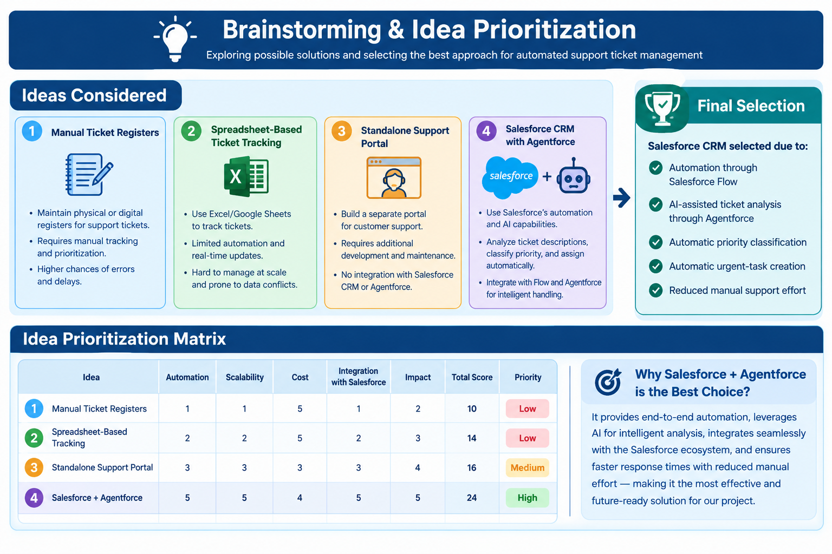

3. REQUIREMENT ANALYSIS PHASE

3.1 Customer Journey Map
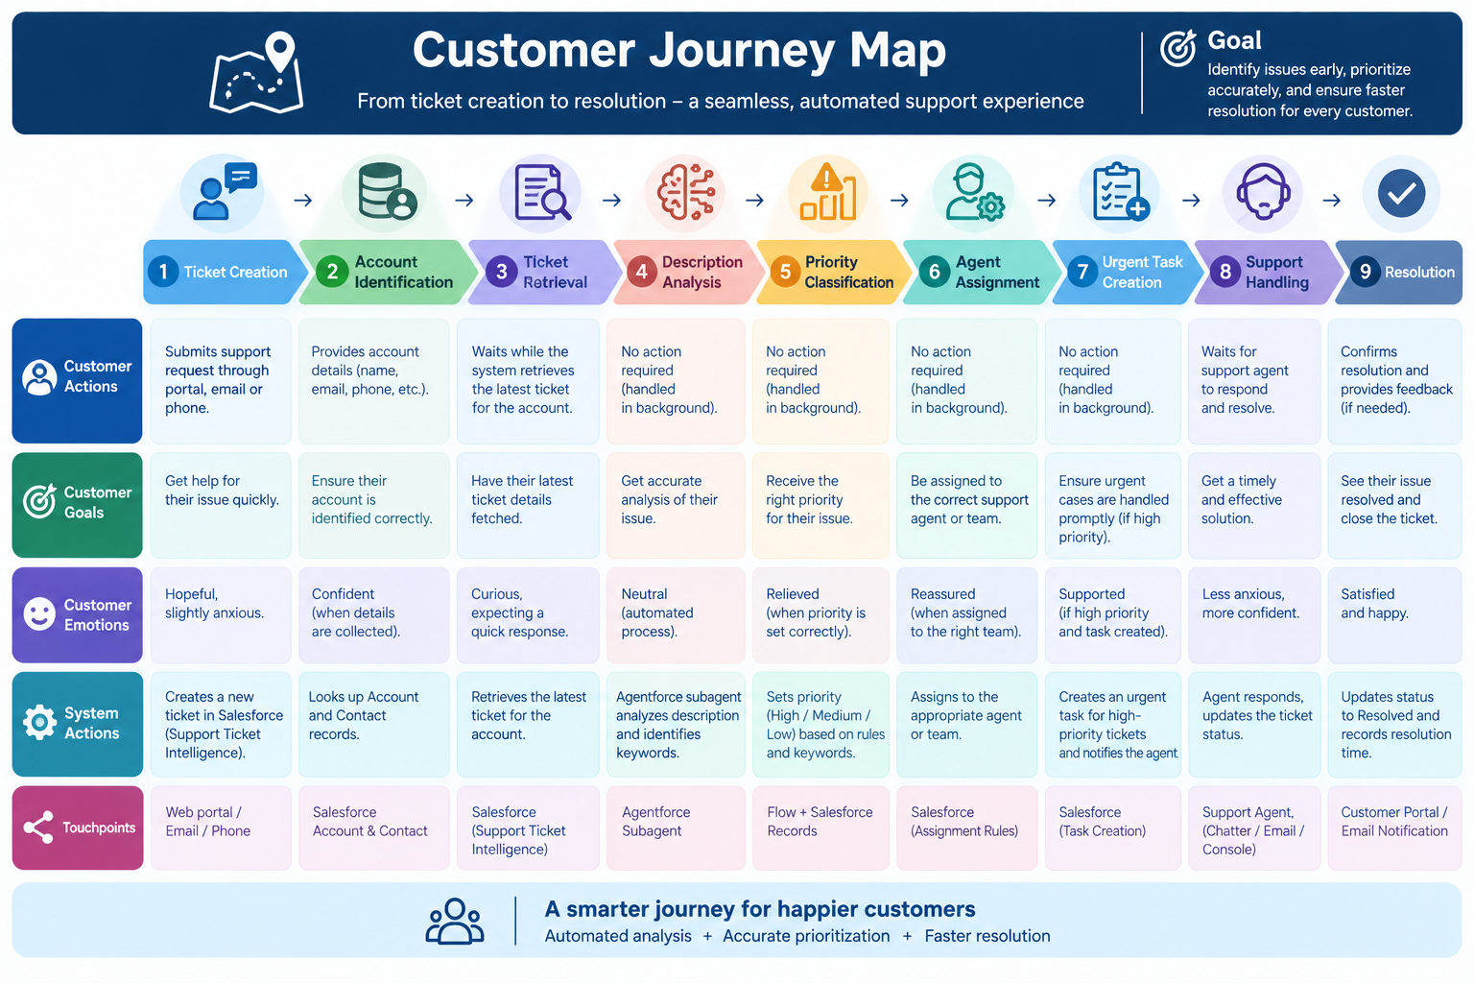
The journey moves from a customer issue to structured Salesforce data, automated analysis and support handling. The key automation checkpoints are ticket retrieval, description analysis, priority classification, assignment and urgent-task creation.

3.2 Functional Requirements
ID | Requirement | Description
FR-01 | Ticket Management | Create and maintain Support Ticket Intelligence records.
FR-02 | Account Association | Associate the ticket with an Account and optionally a Contact.
FR-03 | Latest Ticket Retrieval | Find the most recent ticket for the requested Account.
FR-04 | Description Analysis | Evaluate configured urgency indicators in the description.
FR-05 | Priority Classification | Return High, Medium or Low.
FR-06 | High-Priority Task | Create Urgent Ticket Handling Task for High priority.
FR-07 | Support Assignment | Return the configured support level.
FR-08 | Agentforce Interaction | Allow the user to request analysis conversationally.
FR-09 | SLA Risk Check | Provide an optional check for older unresolved tickets.

3.3 Non-Functional Requirements

Quality | Requirement
Usability | Agentforce prompts should be understandable to support users.
Reliability | The same configured conditions should produce consistent results.
Performance | Latest-ticket retrieval and Flow execution should complete quickly.
Security | Customer and ticket information should remain within controlled Salesforce access.
Maintainability | Priority rules and Flow actions should be easy to update.
Scalability | The design should support more tickets and future assignment rules.

3.4 Data Flow

User Account Name → Agentforce Subagent → Flow Input → Account Lookup → Latest Ticket Lookup → Description Analysis → Priority Output → Assignment / Task Action → Agentforce Response.
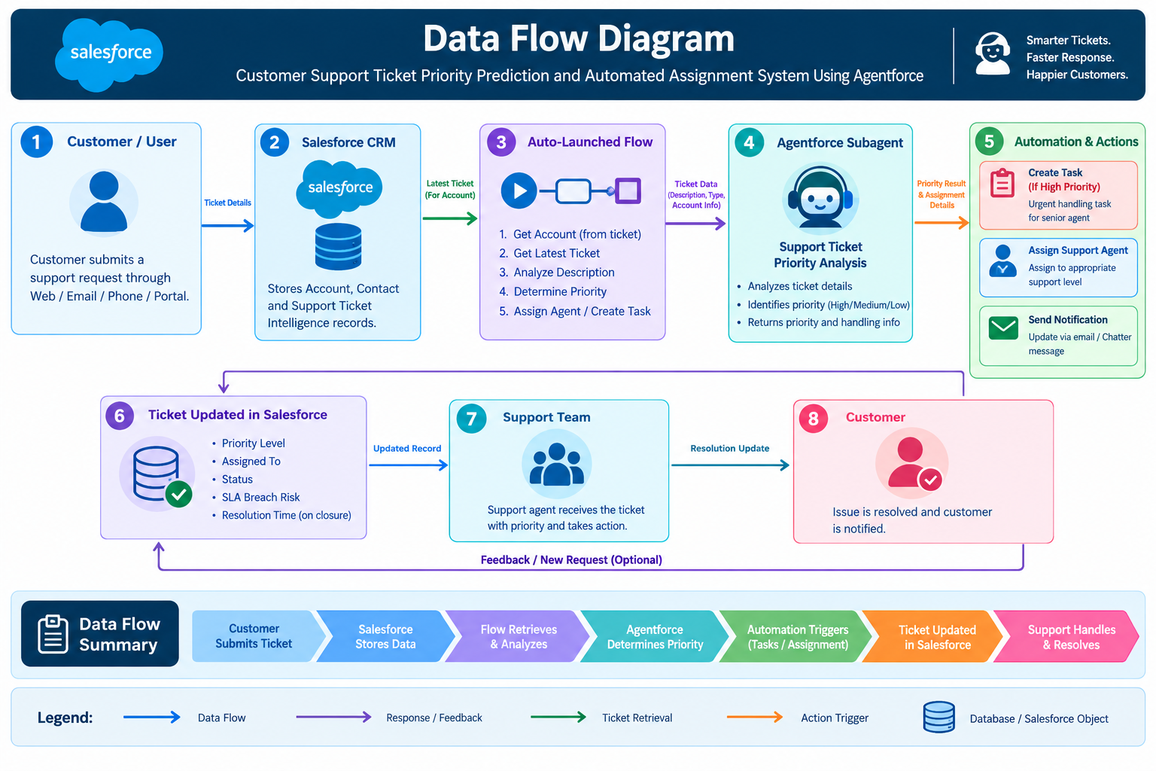

3.5 Technology Stack

Layer | Technology / Component
CRM Platform | Salesforce
Data | Support_Ticket_Intelligence__c, Account, Contact, User, Task
Automation | Auto-Launched Salesforce Flow
AI Interface | Agentforce
Agent Topic | Support Ticket Priority Analysis
Development / Deployment | Salesforce DX and Salesforce CLI
Version Control | Git and GitHub

4. PROJECT DESIGN PHASE

4.1 Problem–Solution Fit

Problem Area | Designed Solution | Result
Manual prioritization | Description-based Flow decision | Priority returned automatically
Urgency can be missed | Explicit High-priority indicators | Urgent path is activated
Manual task creation | Flow creates Task | Less repetitive work
Manual support routing | Assigned support level output | Consistent handling rule
Conversational access | Agentforce subagent | User can request analysis

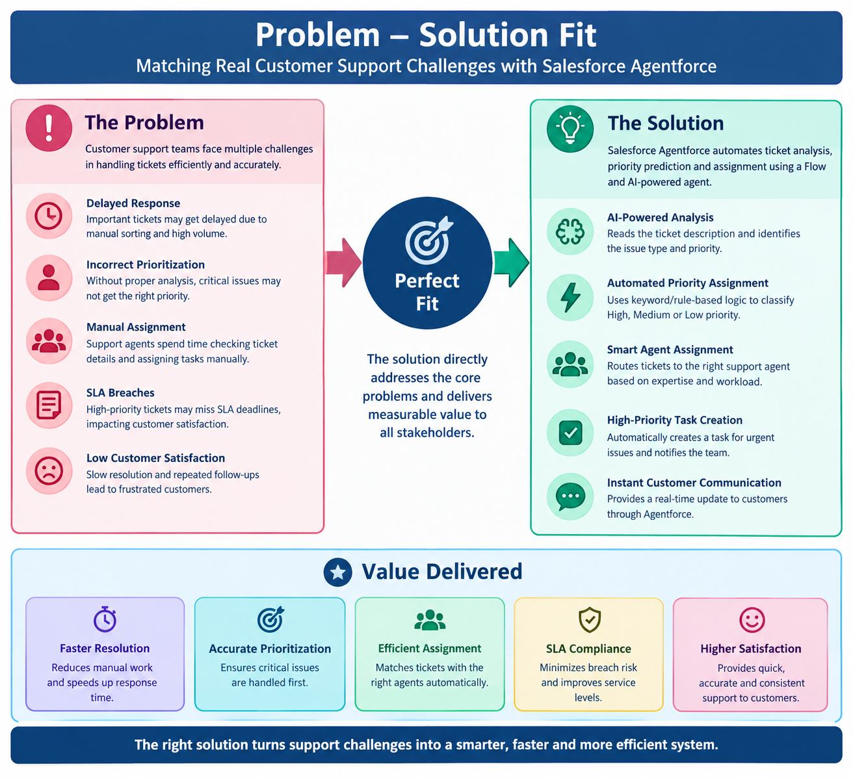

4.2 Proposed Solution

The proposed system combines a structured Salesforce custom object with an Auto-Launched Flow and an Agentforce subagent. Agentforce handles conversational interaction while the Flow performs record retrieval, priority decision logic, assignment output and Task creation.

4.3 Solution Architecture
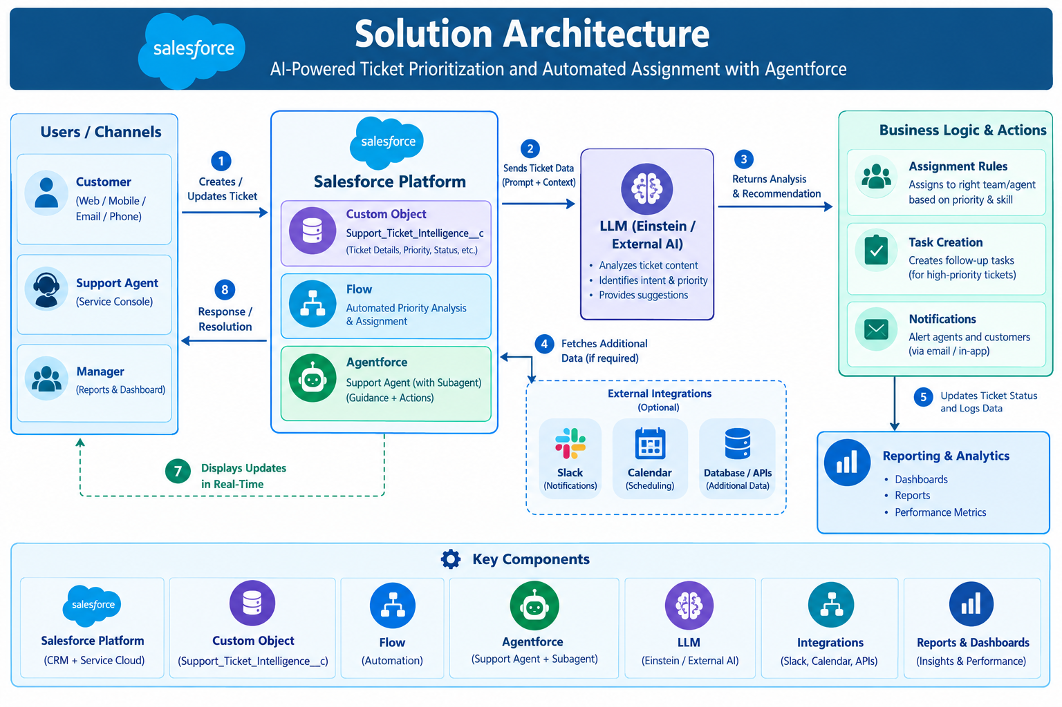

4.4 Data Model Design

The Support Ticket Intelligence object is the central business record. It connects customer context from Account/Contact with issue information and operational fields such as priority, status, assignment and SLA risk. Task records are created for urgent handling.
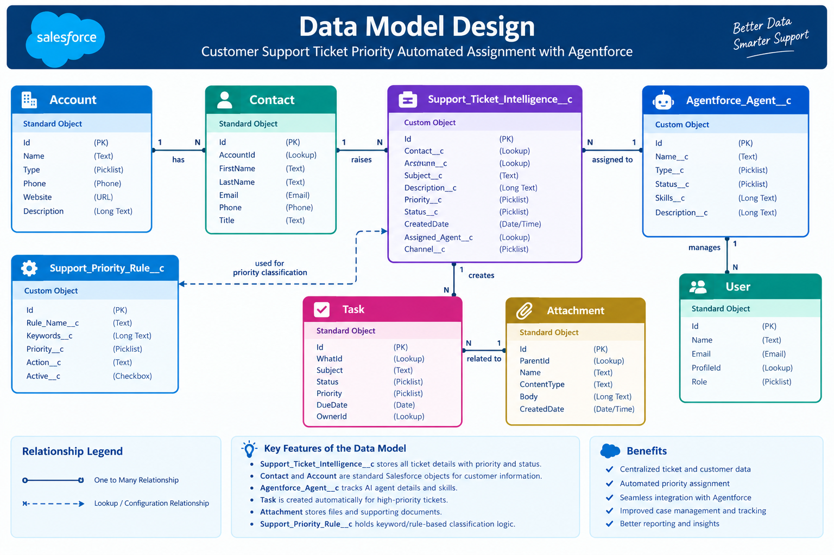

4.5 Priority Decision Logic

The current implementation uses configured description keywords. High priority indicators are 'urgent', 'not working' and 'failure'. Medium indicators are 'issue', 'slow' and 'delay'. If none are detected, the default is Low.

5. PROJECT PLANNING & SCHEDULING

5.1 Agile Planning
- Break the project into small functional increments.
- Implement the data model before automation.
- Validate Flow behavior before connecting Agentforce.
- Test High, Medium and Low paths independently.
- Use Git to maintain the Salesforce project source.

5.2 Product Backlog

ID | Epic | User Story / Task | Points
US-01 | Environment | Configure Salesforce project and development environment | 3
US-02 | Data Model | Create Support Ticket Intelligence custom object | 5
US-03 | Data Model | Create Account and Contact relationships | 3
US-04 | Automation | Build Auto-Launched Flow | 5
US-05 | Automation | Implement priority decision logic | 5
US-06 | Agentforce | Create Support Ticket Priority Analysis subagent | 8
US-07 | Assignment | Create High-priority Task and assignment output | 5
US-08 | SLA | Add optional SLA-risk checking | 5
US-09 | Testing | Validate Agentforce conversation and Flow outputs | 5
US-10 | Version Control | Retrieve Salesforce metadata and push to GitHub | 3

5.3 Sprint Roadmap
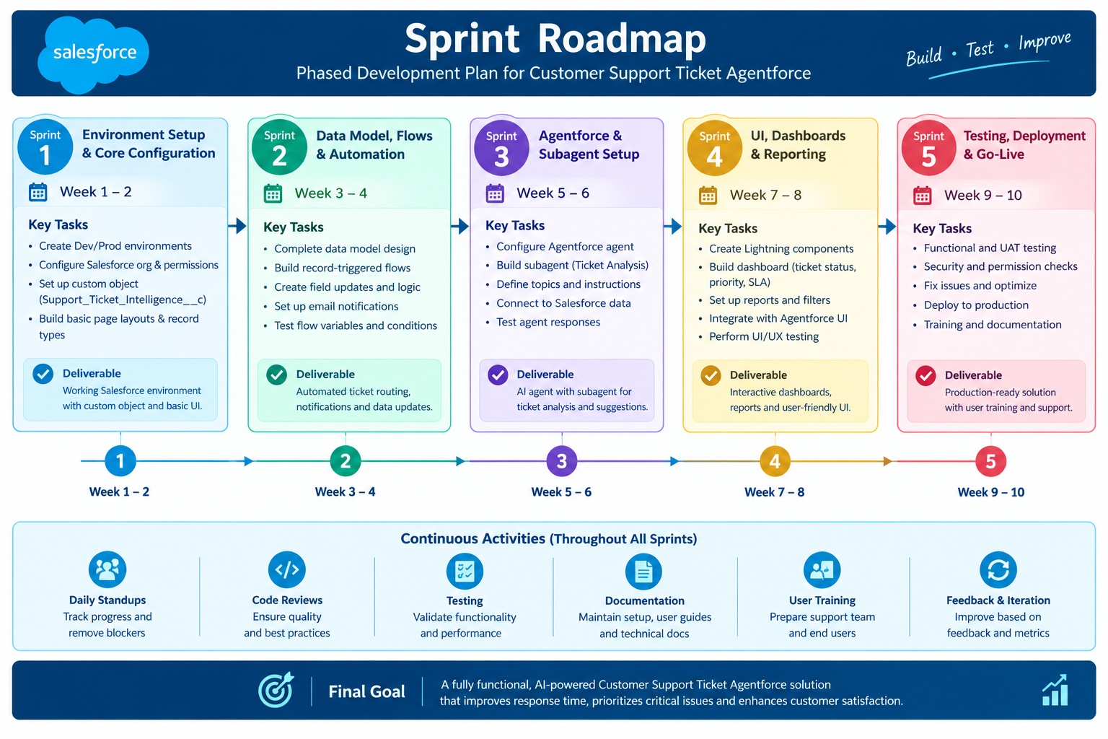

5.4 Project Tracking

Sprint | Main Deliverable | Validation Point
Sprint 1 | Salesforce environment | Org access and project initialized
Sprint 2 | Custom object and fields | Records can be stored
Sprint 3 | Flow automation | Priority and Task behavior verified
Sprint 4 | Agentforce integration | Conversation invokes Flow
Sprint 5 | Testing and refinement | High/Medium/Low scenarios validated

6. PROJECT DEVELOPMENT PHASE

6.1 Salesforce Environment
The development environment uses Salesforce and a Salesforce DX project. The project source is maintained locally and synchronized with GitHub so metadata such as objects, flows and Agentforce configuration can be versioned.
Component | Project Value
Salesforce Org | Runtime configuration and testing
Salesforce DX Project | Local source representation
Salesforce CLI | Retrieve, inspect and deploy metadata
Git | Version control
GitHub | Remote project repository

6.2 Custom Object
Property | Value
Label | Support Ticket Intelligence
API Name | Support_Ticket_Intelligence__c
Purpose | Stores customer support ticket information for analysis and automated handling
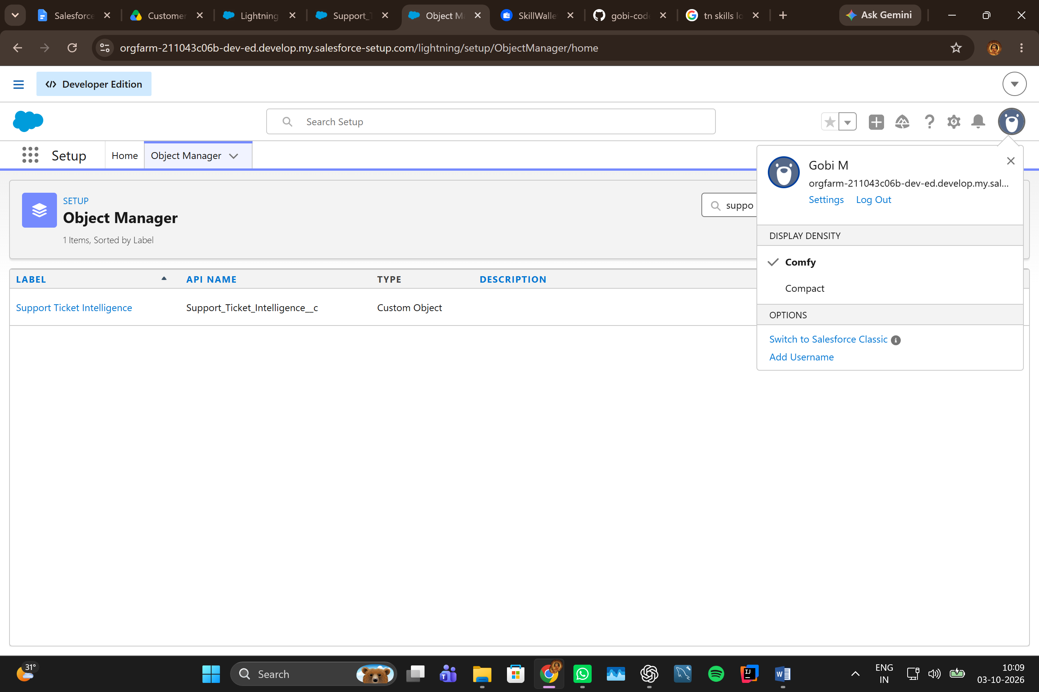

6.3 Fields and Relationships
Field | API Name | Type | Purpose
Ticket Number | Ticket_Number__c | Auto Number | Unique ticket identifier
Customer | Customer__c | Lookup(Account) | Links ticket to customer account
Contact | Contact__c | Lookup(Contact) | Links ticket to customer contact
Issue Type | Issue_Type__c | Picklist | Technical, Billing or General
Description | Description__c | Long Text Area | Stores issue details
Priority Level | Priority_Level__c | Picklist | Low, Medium or High
Status | Status__c | Picklist | New, In Progress or Resolved
Created Date | Created_Date__c | Date | Ticket date
Assigned To | Assigned_To__c | Lookup(User) | Support agent reference
SLA Breach Risk | SLA_Breach_Risk__c | Checkbox | Risk flag
Resolution Time | Resolution_Time_hrs__c | Number | Resolution duration in hours in the current org
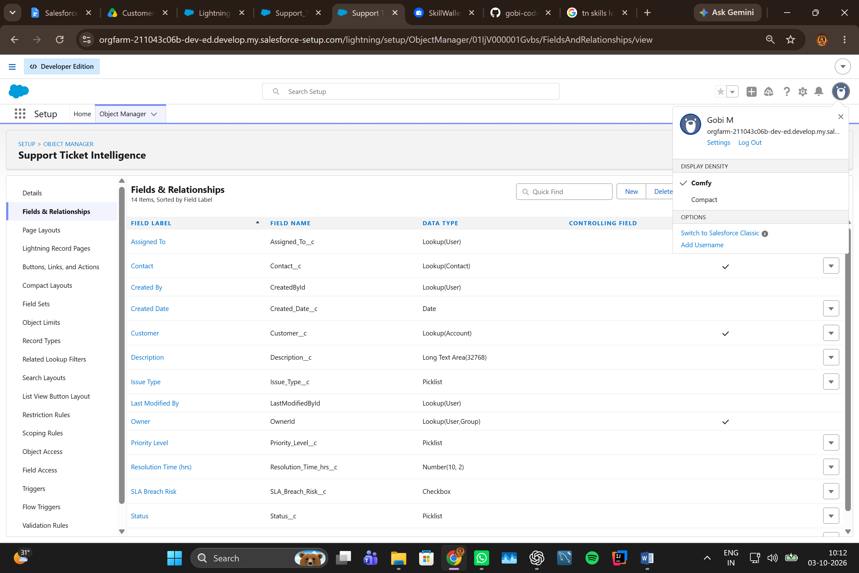

6.4 Flow Design
Flow type: Auto-Launched Flow. Input: Account Name. Outputs: Account Id, Ticket Id, Priority Level, Assigned Agent and Action Message.
Variable | Type | Purpose
varAccountName | Text / Input | Account provided by Agentforce
varAccountId | Text / Output | Resolved Account Id
varTicketId | Text / Output | Latest Support Ticket Id
varPriorityLevel | Text / Output | High / Medium / Low
varAssignedTo | Text / Output | Support handling level
varActionMessage | Text / Output | Human-readable result

6.5 Flow Implementation
Stage | Implementation
1. Account Lookup | Get Account where Name equals varAccountName; latest record first.
2. Account Id | Store Get Account Id in varAccountId.
3. Ticket Lookup | Get latest Support Ticket where Customer__c equals varAccountId.
4. Ticket Id | Store Get Ticket Id in varTicketId.
5. Description Decision | Check configured High and Medium urgency indicators.
6. Priority Assignment | Set varPriorityLevel to High, Medium or Low.
7. High Handling | Create Urgent Ticket Handling Task for High priority.
8. Assignment | Set varAssignedTo to Senior Support Agent for High path.
9. SLA Check | Optionally check whether the ticket is older than two days.
10. Final Message | Return the corresponding action message.
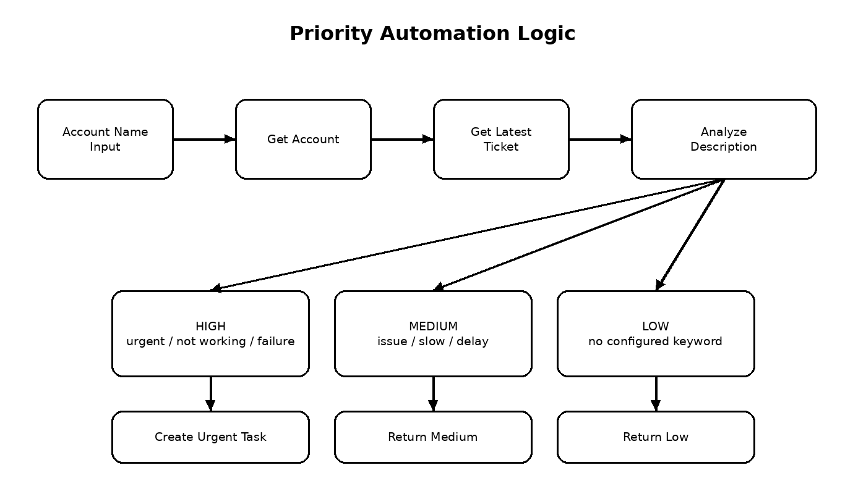
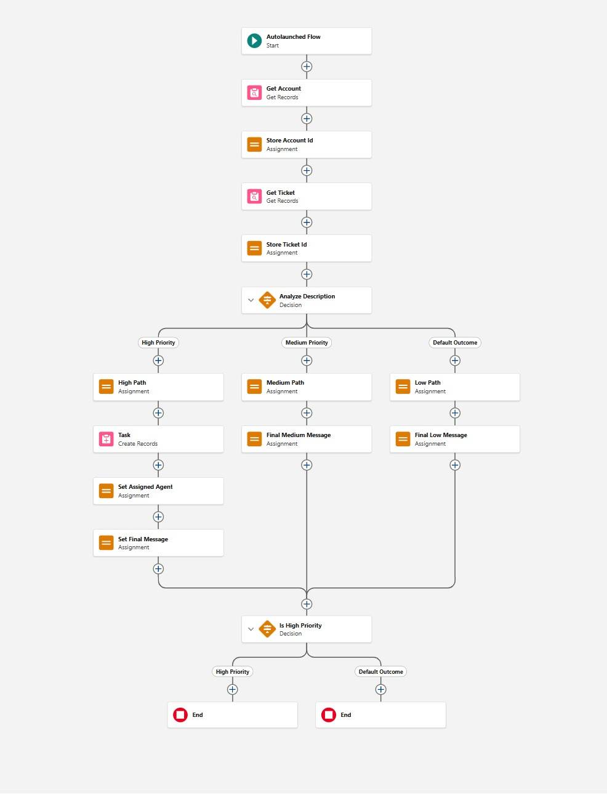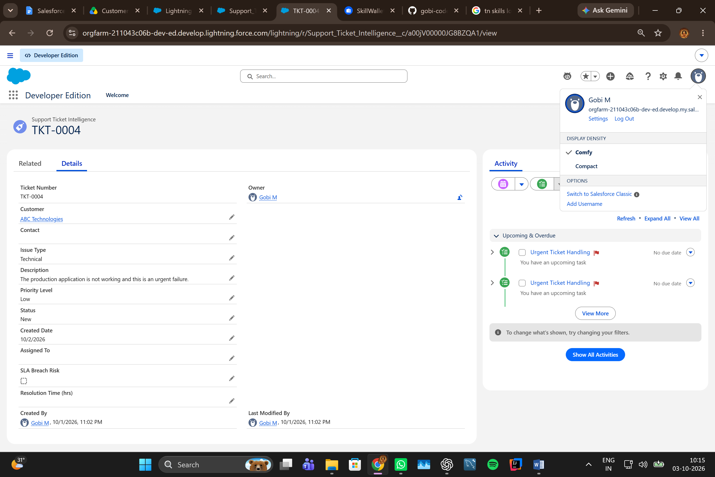

6.6 Agentforce Configuration

The Agentforce configuration uses a subagent named Support Ticket Priority Analysis. Its scope is limited to ticket analysis, priority determination and triggering the backend Flow action. It is instructed not to perform unrelated billing, subscription or account-update tasks.

6.7 Agentforce Action

Property | Configuration
Action | Support Ticket Intelligence Flow action
Input | varAccountName
Loading Text | Analyzing ticket details and determining priority...
Backend | Support_Ticket_Intellegence Auto-Launched Flow
Purpose | Retrieve the latest ticket, analyze priority and return handling outputs

6.8 Input and Output Contract

Direction | Variable | Meaning
Input | varAccountName | Customer Account Name
Output | varAccountId | Account identifier
Output | varTicketId | Analyzed ticket identifier
Output | varPriorityLevel | Calculated priority
Output | varAssignedTo | Assigned support level
Output | varActionMessage | Final handling message

7. FUNCTIONAL & PERFORMANCE TESTING

7.1 Test Strategy

Testing covers the complete automation chain: input collection, Account lookup, ticket retrieval, priority decision, Task creation, assignment output and Agentforce response.

7.2 Test Cases

Test ID | Scenario | Input Condition | Expected Result
TC-01 | High priority | Description contains urgent | Priority = High
TC-02 | High priority | Description contains not working | Priority = High
TC-03 | High priority | Description contains failure | Priority = High1
TC-04 | Medium priority | Description contains issue | Priority = Medium
TC-05 | Medium priority | Description contains slow or delay | Priority = Medium
TC-06 | Low priority | No configured urgency keyword | Priority = Low
TC-07 | High task | High priority returned | Urgent Ticket Handling Task created
TC-08 | Agentforce | Account Name supplied | Agentforce returns analysis outputs

7.3 High-Priority Task Validation

The High-priority scenario was validated with a ticket description containing multiple High indicators. The resulting Task used the configured subject 'Urgent Ticket Handling', Priority 'High' and Status 'Not Started', and was related to the support ticket through WhatId.
Validation | Observed Configuration
Task Subject | Urgent Ticket Handling
Priority | High
Status | Not Started
Related Record | Support Ticket Intelligence
Assigned Support Level | Senior Support Agent

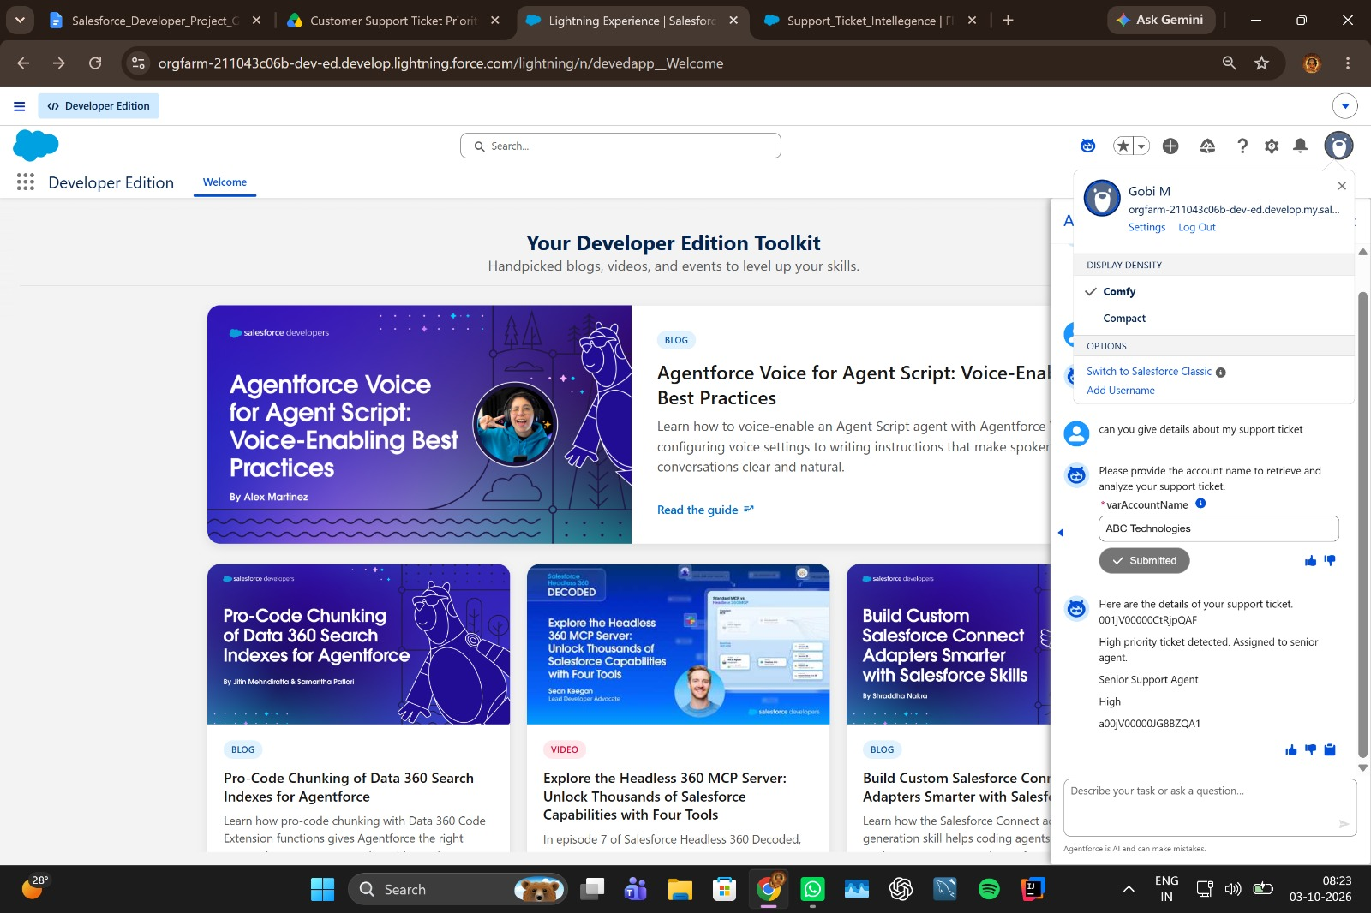

7.4 Agentforce Validation
A successful Agentforce test should return the ticket identifier, calculated priority, assigned support level and action message after the Flow action executes.

7.5 Test Summary
- Account and latest-ticket retrieval are part of the automated Flow.
- High, Medium and Low outcomes follow the configured decision rules.
- High-priority cases trigger urgent Task creation.
- Agentforce provides the conversational entry point to the automation.
- The implementation is deterministic keyword-based classification rather than a trained ML classifier.

8. ADVANTAGES & DISADVANTAGES

8.1 Advantages
- Reduces manual ticket prioritization.
- Creates a clear High-priority handling path.
- Automates urgent Task creation.
- Provides conversational access through Agentforce.
- Uses Salesforce records as the source of operational data.
- Separates conversational AI from controlled backend Flow actions.
- Can be extended with additional assignment and SLA rules.
- Can be version-controlled as Salesforce DX metadata.

8.2 Disadvantages
- Priority classification depends on configured keywords.
- Keyword matching may not understand complex context or indirect urgency.
- The latest-ticket lookup depends on correct Account association.
- Flow and Agentforce configuration must be maintained as requirements change.
- Current assignment output is simple and can be expanded for multiple teams.
- SLA monitoring is currently limited rather than a full escalation engine.
- Advanced analytics are not part of the current implementation.
- True predictive ML classification would require a future model and training dataset.

9. CONCLUSION
The project demonstrates an end-to-end Salesforce support automation workflow in which Agentforce provides conversational interaction and Salesforce Flow performs controlled backend processing. The system identifies the latest support ticket for an Account, analyzes its description, determines priority, creates urgent work for High-priority cases and returns a structured result. The design provides a practical foundation for expanding toward richer assignment, SLA monitoring, analytics and future ML-based classification.

10. FUTURE SCOPE
- Introduce additional urgency indicators and business rules.
- Add a trained machine-learning priority classifier for true predictive scoring.
- Use historical resolution data to improve priority and SLA-risk prediction.
- Support multiple teams with workload-aware assignment.
- Add escalation notifications and richer SLA monitoring.
- Build dashboards for priority distribution, response time and resolution trends.
- Expand Agentforce outputs with ticket status, issue type and recommended next actions.
- Add confidence scores and explanation fields for future AI-based classification.

11. APPENDIX

A. Custom Object
Support_Ticket_Intelligence__c

B. Key Salesforce Records
- Account
- Contact
- Support Ticket Intelligence
- User
- Task

C. Flow
Support_Ticket_Intellegence – Auto-Launched Flow

D. Agentforce Subagent
Support Ticket Priority Analysis

E. Agentforce Action
Flow-based Support Ticket Intelligence action with Account Name input and ticket-analysis outputs.

F. Original Visuals Included
- Project ecosystem
- Support Agent empathy map
- Solution ideation matrix
- Customer support journey
- System requirements model
- Solution architecture
- Data model
- Priority automation logic
- Agentforce conversation flow
- Development roadmap
- Functional test coverage
- Future enhancement roadmap

THANK YOU

